JAVASCRIPT QUESTIONS GITHUB

<https://github.com/ganqqwerty/123-Essential-JavaScript-Interview-Questions>

MOST IMP JAVASCRIPT INTERVIEW QUESTIONS

<https://javascriptcentric.medium.com/top-30-javascript-interview-questions-and-answers-for-2024-7f1e2d1d0638>

**Is javascript a statically typed or a dynamically typed language?**

JavaScript is a dynamically typed language. In a dynamically typed language, variable types are determined at runtime, allowing a variable to hold values of any type without explicit type declarations. This flexibility can make coding more convenient but may also lead to runtime errors if types are not handled appropriately. JavaScript, being dynamically typed, allows variables to change types during execution and accommodates a wide range of data types without explicit type annotations.

**What is Temporal Dead Zone in Javascript?**

The Temporal Dead Zone is a phenomenon in JavaScript associated with the use of the let and const keywords, unlike the var keyword. In ECMAScript 6, attempting to access a let or const variable before it is declared within its scope results in a ReferenceError. The term "temporal dead zone" refers to the timeframe during which this occurs, spanning from the creation of the variable's binding to its actual declaration. Let's illustrate this behaviour with an example:

function exampleMethod() {

console.log(value1);

console.log(value2);

var value1 = 1;

let value2 = 2;

} // Outputs: undefined

// Throws a ReferenceError

In this example, attempting to access before its declaration causes a ReferenceError due to the temporal dead zone, while accessing results in an output of .

**Explain Implicit Type Coercion in javascript.**

Implicit type coercion in javascript is the automatic conversion of value from one data type to another. It takes place when the operands of an expression are of different data types.

* **String coercion**

String coercion takes place while using the ‘ + ‘ operator. When a number is added to a string, the number type is always converted to the string type.

Example 1:

**var** x = 3;

**var** y = "3";

x + y // Returns "33"

### What do you mean by Self Invoking Functions?

Without being requested, a self-invoking expression is automatically invoked (initiated). If a function expression is followed by (), it will execute automatically. A function declaration cannot be invoked by itself.

Normally, we declare a function and call it, however, anonymous functions may be used to run a function automatically when it is described and will not be called again. And there is no name for these kinds of functions.

**What is the difference between exec () and test () methods in javascript?**

* **test ()** and **exec ()** are RegExp expression methods used in javascript.
* We'll use **exec ()** to search a string for a specific pattern, and if it finds it, it'll return the pattern directly; else, it'll return an 'empty' result.
* We will use a**test ()** to find a string for a specific pattern. It will return the Boolean value 'true' on finding the given text otherwise, it will return 'false'.

### What is currying in JavaScript?

**Currying is an advanced technique to transform a function of arguments n, to n functions of one arguments.** Instead of taking all arguments at once, a curried function takes the first argument, then returns another function that takes the next argument, and so on, until all arguments have been provided.

#### Traditional Function

function add(a, b, c) {

return a + b + c;

}

add(1, 2, 3); // Returns 6

#### Curried Function

function curriedAdd(a) {

return function(b) {

return function(c) {

return a + b + c;

};

};

}

// Using the curried function

curriedAdd(1)(2)(3); // Returns 6

// Partial application

const addOne = curriedAdd(1);

const addOneAndTwo = addOne(2);

addOneAndTwo(3); // Returns 6

### What are the types of errors in javascript?

There are two types of errors in javascript.

1. **Syntax error**: Syntax errors are mistakes or spelling problems in the code that cause the program to not execute at all or to stop running halfway through. Error messages are usually supplied as well.
2. **Logical error**: Reasoning mistakes occur when the syntax is proper but the logic or program is incorrect. The application executes without problems in this case. However, the output findings are inaccurate. These are sometimes more difficult to correct than syntax issues since these applications do not display error signals for logic faults.

### 25. What is memoization?

Memoization is a form of caching where the return value of a function is cached based on its parameters. If the parameter of that function is not changed, the cached version of the function is returned.  
Let’s understand memoization, by converting a simple function to a memoized function:

Note- Memoization is used for expensive function calls but in the following example, we are considering a simple function for understanding the concept of memoization better.

Consider the following function:

**function** **addTo256**(num){

**return** num + 256;

}

addTo256(20); // Returns 276

addTo256(40); // Returns 296

addTo256(20); // Returns 276

In the code above, we have written a function that adds the parameter to 256 and returns it. When we are calling the function addTo256 again with the same parameter (“20” in the case above), we are computing the result again for the same parameter. Computing the result with the same parameter, again and again, is not a big deal in the above case, but imagine if the function does some heavy-duty work, then, computing the result again and again with the same parameter will lead to wastage of time.

This is where memoization comes in, by using memoization we can store(cache) the computed results based on the parameters. If the same parameter is used again while invoking the function, instead of computing the result, we directly return the stored (cached) value.

Let’s convert the above function addTo256, to a memoized function:

**function** **memoizedAddTo256**(){

**var** cache = {};

**return** **function**(num){

**if**(num **in** cache){

console.log("cached value");

**return** cache[num]

}

**else**{

cache[num] = num + 256;

**return** cache[num];

}

}

}

**var** memoizedFunc = memoizedAddTo256();

memoizedFunc(20); // Normal return

memoizedFunc(20); // Cached return

In the code above, if we run the memoizedFunc function with the same parameter, instead of computing the result again, it returns the cached result.

Note- Although using memoization saves time, it results in larger consumption of memory since we are storing all the computed results.

### 26. What is recursion in a programming language?

Recursion is a technique to iterate over an operation by having a function call itself repeatedly until it arrives at a result.

function add(number) {

if (number <= 0) {

return 0;

} else {

return number + add(number - 1);

}

}

add(3) => 3 + add(2)

3 + 2 + add(1)

3 + 2 + 1 + add(0)

3 + 2 + 1 + 0 = 6

Example of a recursive function:  
  
The following function calculates the sum of all the elements in an array by using recursion:

function computeSum(arr){

if(arr.length === 1){

return arr[0];

}

else{

return arr.pop() + computeSum(arr);

}

}

computeSum([7, 8, 9, 99]); // Returns 123

### 27. What is the use of a constructor function in javascript?

Constructor functions are used to create objects in javascript.

When do we use constructor functions?

If we want to create multiple objects having similar properties and methods, constructor functions are used.

#### **Note- The name of a constructor function should always be written in Pascal Notation: every word should start with a capital letter.**

Example:

**function** **Person**(name,age,gender){

this.name = name;

this.age = age;

this.gender = gender;

}

**var** person1 = **new** Person("Vivek", 76, "male");

console.log(person1);

**var** person2 = **new** Person("Courtney", 34, "female");

console.log(person2);

In the code above, we have created a constructor function named Person. Whenever we want to create a new object of the type Person, We need to create it using the new keyword:

**var** person3 = **new** Person("Lilly", 17, "female");

The above line of code will create a new object of the type Person. Constructor functions allow us to group similar objects.

**4. What is the rest parameter and spread operator?**

Both rest parameter and spread operator were introduced in the ES6 version of javascript.  
  
**Rest parameter ( … ):**

* It provides an improved way of handling the parameters of a function.
* Using the rest parameter syntax, we can create functions that can take a variable number of arguments.
* Any number of arguments will be converted into an array using the rest parameter.
* It also helps in extracting all or some parts of the arguments.
* Rest parameters can be used by applying three dots (...) before the parameters.

**function** **extractingArgs**(...args){

**return** args[1];

}

// extractingArgs(8,9,1); // Returns 9

**function** **addAllArgs**(...args){

**let** sumOfArgs = 0;

**let** i = 0;

**while**(i < args.length){

sumOfArgs += args[i];

i++;

}

**return** sumOfArgs;

}

addAllArgs(6, 5, 7, 99); // Returns 117

addAllArgs(1, 3, 4); // Returns 8

**\*\*Note- Rest parameter should always be used at the last parameter of a function:**

// Incorrect way to use rest parameter

**function** **randomFunc**(a,...args,c){

//Do something

}

// Correct way to use rest parameter

**function** **randomFunc2**(a,b,...args){

//Do something

}

* **Spread operator (…):**

**Arrays**: The spread operator can expand the elements of an array into individual elements. This is particularly useful for copying arrays or merging multiple arrays.

**Example: Copying an Array**

const arr1 = [1, 2, 3];

const arr2 = [...arr1];

console.log(arr2); // Output: [1, 2, 3]

**Example: Merging Arrays**

const arr1 = [1, 2, 3];

const arr2 = [4, 5, 6];

const mergedArr = [...arr1, ...arr2];

console.log(mergedArr); // Output: [1, 2, 3, 4, 5, 6]

**Example: Expanding Arrays**

**let originalArray = [1, 2, 3];**

**console.log(originalArray); // Output: [1, 2, 3]**

**originalArray = [...originalArray, 4];**

**console.log(originalArray); // Output: [1, 2, 3]**

**Objects**: The spread operator can copy properties from one object to another, creating a new object with those properties. It's useful for merging objects or creating shallow copies of objects.

**Example: Copying an Object**

const obj1 = { a: 1, b: 2 };

const obj2 = { ...obj1 };

console.log(obj2); // Output: { a: 1, b: 2 }

**Example: Merging Objects**

const obj1 = { a: 1, b: 2 };

const obj2 = { b: 3, c: 4 };

const mergedObj = { ...obj1, ...obj2 };

console.log(mergedObj); // Output: { a: 1, b: 3, c: 4 }

**7. What are classes in javascript?**

Introduced in the ES6 version, classes are nothing but syntactic sugars for constructor functions. They provide a new way of declaring constructor functions in javascript.  Below are the examples of how classes are declared and used:

// Before ES6 version, using constructor functions

**function** **Student**(name,rollNumber,grade,section){

this.name = name;

this.rollNumber = rollNumber;

this.grade = grade;

this.section = section;

}

// Way to add methods to a constructor function

Student.prototype.getDetails = **function**(){

**return** 'Name: ${this.name}, Roll no: ${this.rollNumber}, Grade: ${this.grade}, Section:${this.section}';

}

**let** student1 = **new** Student("Vivek", 354, "6th", "A");

student1.getDetails();

// Returns Name: Vivek, Roll no:354, Grade: 6th, Section:A

// ES6 version classes

**class** **Student**{

**constructor**(name,rollNumber,grade,section){

this.name = name;

this.rollNumber = rollNumber;

this.grade = grade;

this.section = section;

}

// Methods can be directly added inside the class

**getDetails**(){

**return** 'Name: ${this.name}, Roll no: ${this.rollNumber}, Grade:${this.grade}, Section:${this.section}';

}

}

**let** student2 = **new** Student("Garry", 673, "7th", "C");

student2.getDetails();

// Returns Name: Garry, Roll no:673, Grade: 7th, Section:C

Key points to remember about classes:

* Unlike functions, classes are not hoisted. A class cannot be used before it is declared.
* A class can inherit properties and methods from other classes by using the extend keyword.
* All the syntaxes inside the class must follow the strict mode(‘use strict’) of javascript. An error will be thrown if the strict mode rules are not followed.

### What is Class Inheritance

JavaScript classes can be extended to create new classes that inherit properties and methods from the parent class. This is done using the extends keyword.

**Example: Basic Class Inheritance**

class Animal {

constructor(name) {

this.name = name;

}

speak() {

console.log(`${this.name} makes a noise.`);

}

}

class Dog extends Animal {

speak() {

console.log(`${this.name} barks.`);

}

}

const dog = new Dog('Rex');

dog.speak(); // Output: Rex barks.

In this example:

* The Dog class extends the Animal class, inheriting its properties and methods.
* The speak method in the Dog class overrides the speak method in the Animal class.
* When dog.speak() is called, the overridden method in the Dog class is executed.

**Constructor Chaining**: In an extended class, you can call the constructor of the parent class using super() to ensure the parent class is correctly initialized.

class Animal {

constructor(name) {

this.name = name;

}

}

class Dog extends Animal {

constructor(name, breed) {

super(name); // Calls the constructor of Animal

this.breed = breed;

}

describe() {

console.log(`${this.name} is a ${this.breed}.`);

}

}

const dog = new Dog('Rex', 'German Shepherd');

dog.describe(); // Output: Rex is a German Shepherd.

Here, the Dog class uses super(name) to call the constructor of Animal, ensuring that the name property is correctly initialized in the parent class. The Dog class also introduces a new property, breed.

**Explain Inheritance in Javascript.**

In JavaScript, inheritance is a way to create a new object based on an existing object, allowing the new object to reuse and extend the properties and methods of the original object. There are two main ways to implement inheritance in JavaScript:

### ****Prototype-based Inheritance:****

JavaScript uses prototypes to define the properties and methods that objects can inherit. Each object has a private property called [[Prototype]] (commonly accessed via \_\_proto\_\_ in browsers) that references another object, which is its prototype.

* **Creating Inheritance Using Object.create():** This method allows you to create a new object with the specified prototype.

const parent = {

sayHello() {

console.log("Hello from parent!");

}

};

const child = Object.create(parent);

child.sayHello(); // Output: Hello from parent!

* **Using Constructor Functions and Prototypes:** Before ES6 classes, JavaScript developers used constructor functions and the prototype property to implement inheritance.

function Parent(name) {

this.name = name;

}

Parent.prototype.sayHello = function() {

console.log(`Hello, my name is ${this.name}`);

};

function Child(name, age) {

Parent.call(this, name);

this.age = age;

}

Child.prototype = Object.create(Parent.prototype);

Child.prototype.constructor = Child;

const child = new Child("John", 20);

child.sayHello(); // Output: Hello, my name is John

### ****Class-based Inheritance (ES6):****

With the introduction of ES6, JavaScript added a more familiar syntax for inheritance using class and extends.

* **Using Classes:** The class keyword is syntactic sugar over the existing prototype-based inheritance model.

class Parent {

constructor(name) {

this.name = name;

}

sayHello() {

console.log(`Hello, my name is ${this.name}`);

}

}

class Child extends Parent {

constructor(name, age) {

super(name);

this.age = age;

}

}

const child = new Child("John", 20);

child.sayHello(); // Output: Hello, my name is John

In both prototype-based and class-based inheritance, the key concept is that objects or classes can inherit features from other objects or classes, allowing for code reuse and the creation of more complex data structures.

**8. What are generator functions?**

Introduced in the ES6 version, generator functions are a special class of functions. They can be stopped midway and then continue from where they had stopped. Generator functions are declared with the function\* keyword instead of the normal function keyword:

**function**\* **genFunc**(){

// Perform operation

}

In normal functions, we use the **return**keyword to return a value and as soon as the return statement gets executed, the function execution stops:

**function** **normalFunc**(){

**return** 22;

console.log(2); // This line of code does not get executed

}

In the case of generator functions, when called, they do not execute the code, instead, they return a **generator object**. This generator object handles the execution.

**function**\* **genFunc**(){

**yield** 3;

**yield** 4;

}

genFunc(); // Returns Object [Generator] {}

The generator object consists of a method called **next()**, this method when called, executes the code until the nearest **yield**statement, and returns the yield value.  
  
For example, if we run the next() method on the above code:

genFunc().next(); // Returns {value: 3, done:false}

As one can see the next method returns an object consisting of a **value**and **done**properties.  Value property represents the yielded value. Done property tells us whether the function code is finished or not. (Returns true if finished).

Generator functions are used to return iterators. Let’s see an example where an iterator is returned:

**function**\* **iteratorFunc**() {

**let** count = 0;

**for** (**let** i = 0; i < 2; i++) {

count++;

**yield** i;

}

**return** count;

}

**let** iterator = iteratorFunc();

console.log(iterator.next()); // {value:0,done:false}

console.log(iterator.next()); // {value:1,done:false}

console.log(iterator.next()); // {value:2,done:true}

As you can see in the code above, the last line returns **done:true**, since the code reaches the return statement

**12. What is Object Destructuring?**

Object destructuring is a new way to extract elements from an object or an array.

* **Object destructuring:**Before ES6 version:

**const** classDetails = {

strength: 78,

benches: 39,

blackBoard:1

}

**const** classStrength = classDetails.strength;

**const** classBenches = classDetails.benches;

**const** classBlackBoard = classDetails.blackBoard;

The same example using object destructuring:

**const** classDetails = {

strength: 78,

benches: 39,

blackBoard:1

}

**const** {strength:classStrength, benches:classBenches,blackBoard:classBlackBoard} = classDetails;

console.log(classStrength); // Outputs 78

console.log(classBenches); // Outputs 39

console.log(classBlackBoard); // Outputs 1

As one can see, using object destructuring we have extracted all the elements inside an object in one line of code. If we want our new variable to have the same name as the property of an object we can remove the colon:

**const** {strength:strength} = classDetails;

// The above line of code can be written as:

**const** {strength} = classDetails;

* **Array destructuring:**Before ES6 version:

**const** arr = [1, 2, 3, 4];

**const** first = arr[0];

**const** second = arr[1];

**const** third = arr[2];

**const** fourth = arr[3];

The same example using object destructuring:

**const** arr = [1, 2, 3, 4];

**const** [first,second,third,fourth] = arr;

console.log(first); // Outputs 1

console.log(second); // Outputs 2

console.log(third); // Outputs 3

console.log(fourth); // Outputs 4

**13. Difference between prototypal and classical inheritance**

Programers build objects, which are representations of real-time entities, in traditional OO programming. Classes and objects are the two sorts of abstractions. A class is a generalization of an object, whereas an object is an abstraction of an actual thing. A Vehicle, for example, is a specialization of a Car. As a result, automobiles (class) are descended from vehicles (object).

Classical inheritance differs from prototypal inheritance in that classical inheritance is confined to classes that inherit from those remaining classes, but prototypal inheritance allows any object to be cloned via an object linking method. Despite going into too many specifics, a prototype essentially serves as a template for those other objects, whether they extend the parent object or not.

**7. Difference between Async/Await and Generators usage to achieve the same functionality.**

* Generator functions are run by their generator yield by yield which means one output at a time, whereas Async-await functions are executed sequentially one after another.
* Async/await provides a certain use case for Generators easier to execute.
* The output result of the Generator function is always value: X, done: Boolean, but the return value of the Async function is always an assurance or throws an error

### 1. What is the output of the following code?

**const** b = [1, 2, 3, 4, 5, 6, 7, 8, 9, 10];

**for** (**let** i = 0; i < 10; i++) {

setTimeout(() => console.log(b[i]), 1000);

}

**for** (**var** i = 0; i < 10; i++) {

setTimeout(() => console.log(b[i]), 1000);

}

**Ans.**

1

2

3

4

5

6

7

8

9

10

undefined

undefined

undefined

undefined

undefined

undefined

undefined

undefined

undefined

undefined

### Conclusion

It is preferable to keep the JavaScript, CSS, and HTML in distinct Separate 'javascript' files. Dividing the code and HTML sections will make them easier to understand and deal with. This strategy is also simpler for several programmers to use at the same time. JavaScript code is simple to update. Numerous pages can utilize the same group of JavaScript Codes. If we utilize External JavaScript scripts and need to alter the code, we must do it just once. So that we may utilize a number and maintain it much more easily. Remember that professional experience and expertise are only one aspect of recruitment. Previous experience and personal skills are both vital in landing (or finding the ideal applicant for the job.

Remember that many JavaScript structured interviews are free and have no one proper answer. Interviewers would like to know why you answered the way you did, not if you remembered the answer. Explain your answer process and be prepared to address it. If you're looking to further enhance your JavaScript skills, consider enrolling in this free JavaScript course by [Scaler Topics](https://www.scaler.com/topics/course/javascript-beginners/" \t "_blank) to gain hands-on experience and improve your problem-solving abilities.

### Recommended Resources

* [JavaScript Cheat Sheet: Basics to Advanced(2023)](https://www.interviewbit.com/javascript-cheat-sheet/)
* [Online Javascript Compiler](https://www.interviewbit.com/online-javascript-compiler/)
* [Top JavaScript Features You Must Know](https://www.interviewbit.com/blog/javascript-features/)
* [50 JavaScript MCQ With Answers](https://www.interviewbit.com/javascript-mcq/)
* [Top 15+ JavaScript Projects for Beginners to Advanced [With Source Code]](https://www.interviewbit.com/blog/javascript-projects/)
* [9 Best JavaScript IDE & Source Code Editors [2023]](https://www.interviewbit.com/blog/javascript-ide/)
* [Top ES6 Interview Questions (2023)](https://www.interviewbit.com/es6-interview-questions/)
* [10 Best JavaScript Books for Beginners to Advanced [2023]](https://www.interviewbit.com/blog/best-javascript-books/)
* [30+ Top Node.js Interview Questions (2023)](https://www.interviewbit.com/node-js-interview-questions/)
* [Typescript vs Javascript: What’s The Difference?](https://www.interviewbit.com/blog/typescript-vs-javascript/)
* [Top 5 JavaScript Libraries You Must Know in 2023](https://www.interviewbit.com/blog/top-javascript-libraries/)
* [Difference Between HTML and JavaScript](https://www.interviewbit.com/blog/difference-between-html-and-javascript/)
* [Javascript Vs jQuery: What’s the Difference? [2023]](https://www.interviewbit.com/blog/javascript-vs-jquery/)
* [Javascript Vs Python: What’s The Difference? [2023]](https://www.interviewbit.com/blog/javascript-vs-python/)
* [Difference Between Java and Javascript](https://www.interviewbit.com/blog/difference-between-java-and-javascript/)
* [Difference between Typescript and Javascript](https://www.interviewbit.com/blog/typescript-vs-javascript/)

### Interview Guides

* [The Ultimate Guide to Acing Your Technical Interview](https://www.interviewbit.com/technical-interview-questions/)
* [300+ Must Do Coding Questions from Interviews](https://www.interviewbit.com/coding-interview-questions/)
* [Mock Interview](https://www.interviewbit.com/mock-interview/)
* [InterviewBit - No.1 Resource for Tech Interview Preparation](https://www.interviewbit.com/blog)

### 2. In JavaScript, how do you turn an Object into an Array []?

**let** obj = { id: "1", name: "user22", age: "26", work: "programmer" };

//Method 1: Convert the keys to Array using - Object.keys()

console.log(Object.keys(obj));

// ["id", "name", "age", "work"]

// Method 2 Converts the Values to Array using - Object.values()

console.log(Object.values(obj));

// ["1", "user22r", "26", "programmer"]

// Method 3 Converts both keys and values using - Object.entries()

console.log(Object.entries(obj));

//[["id", "1"],["name", "user22"],["age", "26"],["work", “programmer"]]

### 3. Write the code to find the vowels

**const** findVowels = str => {

**let** count = 0

**const** vowels = ['a', 'e', 'i', 'o', 'u']

**for**(**let** char **of** str.toLowerCase()) {

**if**(vowels.includes(char)) {

count++

}

}

**return** count

}

### 4. Write the code given If two strings are anagrams of one another, then return true.

**var** firstWord = "Deepak";

**var** secondWord = "Aman";

isAnagram(wordOne, wordTwo); // true

**function** **isAnagram**(one, two) {

//Change both words to lowercase for case insensitivity..

**var** a = one.toLowerCase();

**var** b = two.toLowerCase();

// Sort the strings, then combine the array to a string. Examine the outcomes.

a = a.split("").sort().join("");

b = b.split("").sort().join("");

**return** a === b;

}

### 5. Write the code for dynamically inserting new components.

<html>

<head>

<title>inserting new components dynamically</title>

<script type="text/javascript">

function addNode () { var newP = document. createElement("p");

var textNode = document.createTextNode(" This is other node");

newP.appendChild(textNode); document.getElementById("parent1").appendChild(newP); }

</script>

</head>

<body> <p id="parent1">firstP<p> </body>

</html>

### 6. Implement a function that returns an updated array with r right rotations on an array of integers a .

**Example:**

Given the following array: **[2,3,4,5,7]**  
Perform **3**right rotations:  
First rotation : [7,2,3,4,5] , Second rotation : [5,7,2,3,4] and, Third rotation: [4,5,7,2,3]

return **[4,5,7,2,3]**

**Answer:**

function rotateRight(arr,rotations){

if(rotations == 0) return arr;

for(let i = 0; i < rotations;i++){

let element = arr.pop();

arr.unshift(element);

}

return arr;

}

rotateRight([2, 3, 4, 5, 7], 3); // Return [4,5,7,2,3]

rotateRight([44, 1, 22, 111], 5); // Returns [111,44,1,22]

### 7. Write a function that performs binary search on a sorted array.

**function** **binarySearch**(arr,value,startPos,endPos){

**if**(startPos > endPos) **return** -1;

**let** middleIndex = Math.floor(startPos+endPos)/2;

**if**(arr[middleIndex] === value) **return** middleIndex;

**elsif**(arr[middleIndex] > value){

**return** binarySearch(arr,value,startPos,middleIndex-1);

}

**else**{

**return** binarySearch(arr,value,middleIndex+1,endPos);

}

}

### 8. Guess the outputs of the following code:

#### **\*\*Note - Code 2 and Code 3 require you to modify the code, instead of guessing the output.**

// Code 1

(**function**(a){

**return** (**function**(){

console.log(a);

a = 23;

})()

})(45);

// Code 2

// Each time bigFunc is called, an array of size 700 is being created,

// Modify the code so that we don't create the same array again and again

**function** **bigFunc**(element){

**let** newArray = **new** Array(700).fill('♥');

**return** newArray[element];

}

console.log(bigFunc(599)); // Array is created

console.log(bigFunc(670)); // Array is created again

// Code 3

// The following code outputs 2 and 2 after waiting for one second

// Modify the code to output 0 and 1 after one second.

**function** **randomFunc**(){

**for**(**var** i = 0; i < 2; i++){

setTimeout(()=> console.log(i),1000);

}

}

randomFunc();

**Answers -**  
  
**Code 1**- Outputs **45**.  
  
Even though a is defined in the outer function, due to closure the inner functions have access to it.  
  
**Code 2**- This code can be modified by using closures,

**function** **bigFunc**(){

**let** newArray = **new** Array(700).fill('♥');

**return** (element) => newArray[element];

}

**let** getElement = bigFunc(); // Array is created only once

getElement(599);

getElement(670);

**Code 3**- Can be modified in two ways:  
  
Using **let**keyword:

**function** **randomFunc**(){

**for**(**let** i = 0; i < 2; i++){

setTimeout(()=> console.log(i),1000);

}

}

randomFunc();

**Using closure:**

**function** **randomFunc**(){

**for**(**var** i = 0; i < 2; i++){

(**function**(i){

setTimeout(()=>console.log(i),1000);

})(i);

}

}

randomFunc();

### 9. Guess the outputs of the following code:

// Code 1

let hero = {

powerLevel: 99,

getPower(){

return this.powerLevel;

}

}

let getPower = hero.getPower;

let hero2 = {powerLevel:42};

console.log(getPower());

console.log(getPower.apply(hero2));

// Code 2

const a = function(){

console.log(this);

const b = {

func1: function(){

console.log(this);

}

}

const c = {

func2: ()=>{

console.log(this);

}

}

b.func1();

c.func2();

}

a();

// Code 3

const b = {

name:"Vivek",

f: function(){

var self = this;

console.log(this.name);

(function(){

console.log(this.name);

console.log(self.name);

})();

}

}

b.f();

Answers:  
  
**Code 1**- Output in the following order:

undefined

42

Reason - The first output is **undefined**since when the function is invoked, it is invoked referencing the global object:

window.getPower() = getPower();

**Code 2**- Outputs in the following order:

global/window object

object "b"

global/window object

Since we are using the arrow function inside **func2, this**keyword refers to the global object.  
  
**Code 3**- Outputs in the following order:

"Vivek"

undefined

"Vivek"

Only in the IIFE inside the function **f**, **this**keyword refers to the global/window object.

### 10. Guess the output of the following code:

**var** x = 23;

(**function**(){

**var** x = 43;

(**function** **random**(){

x++;

console.log(x);

**var** x = 21;

})();

})();

### Answer:

Output is **NaN**.  
  
random() function has functional scope since x is declared and hoisted in the functional scope.  
  
Rewriting the random function will give a better idea about the output:

**function** **random**(){

**var** x; // x is hoisted

x++; // x is not a number since it is not initialized yet

console.log(x); // Outputs NaN

x = 21; // Initialization of x

}

### 11. Guess the outputs of the following code:

// Code 1:

**let** x= {}, y = {name:"Ronny"},z = {name:"John"};

x[y] = {name:"Vivek"};

x[z] = {name:"Akki"};

console.log(x[y]);

// Code 2:

**function** **runFunc**(){

console.log("1" + 1);

console.log("A" - 1);

console.log(2 + "-2" + "2");

console.log("Hello" - "World" + 78);

console.log("Hello"+ "78");

}

runFunc();

// Code 3:

**let** a = 0;

**let** b = false;

console.log((a == b));

console.log((a === b));

**Answers:**  
  
**Code 1**- Output will be **{name: “Akki”}.**  
  
Adding objects as properties of another object should be done carefully.  
  
Writing **x[y] = {name:”Vivek”}**, is same as writing **x[‘object Object’] = {name:”Vivek”}**,  
  
While setting a property of an object, **javascript coerces the parameter into a string.**  
  
Therefore, since **y**is an object, it will be converted to **‘object Object’.**  
  
Both x[y] and x[z] are referencing the same property.  
  
**Code 2**- Outputs in the following order:

11

Nan

2-22

NaN

Hello78

**Code 3**- Output in the following order due to equality coercion:

true

false

### 12. Guess the outputs of the following codes:

// Code 1:

**function** **func1**(){

setTimeout(()=>{

console.log(x);

console.log(y);

},3000);

**var** x = 2;

**let** y = 12;

}

func1();

// Code 2:

**function** **func2**(){

**for**(**var** i = 0; i < 3; i++){

setTimeout(()=> console.log(i),2000);

}

}

func2();

// Code 3:

(**function**(){

setTimeout(()=> console.log(1),2000);

console.log(2);

setTimeout(()=> console.log(3),0);

console.log(4);

})();

**Answers:**

* **Code 1**- Outputs **2**and **12**. Since, even though **let**variables are not hoisted, due to the async nature of javascript, the complete function code runs before the setTimeout function. Therefore, it has access to both x and y.
* **Code 2**- Outputs **3**, three times since variable declared with **var**keyword does not have block scope. Also, inside the for loop, the variable i is incremented first and then checked.
* **Code 3**- Output in the following order:

2

4

3

1 // After two seconds

Even though the second timeout function has a waiting time of zero seconds, the javascript engine always evaluates the setTimeout function using the Web API, and therefore, the complete function executes before the setTimeout function can execute.

GEEKSFORGEEKS

**1. What are the differences between Java and JavaScript?**

JavaScript is a client-side scripting language and Java is object Oriented Programming language. Both of them are totally different from each other.

* [**JavaScript**](https://www.geeksforgeeks.org/javascript-tutorial/)**:** It is a light-weighted programming language (“scripting language”) for developing interactive web pages. It can insert dynamic text into the HTML elements. JavaScript is also known as the browser’s language.
* [**Java**](https://www.geeksforgeeks.org/java/)**:** Java is one of the most popular programming languages. It is an object-oriented programming language and has a virtual machine platform that allows you to create compiled programs that run on nearly every platform. Java promised, “Write Once, Run Anywhere”.

### 7. ****What is negative infinity?****

 The negative infinity is a constant value represents the lowest available value. It means that no other number is lesser than this value. It can be generate using a self-made function or by an arithmetic operation. JavaScript shows the NEGATIVE\_INFINITY value as -Infinity.

### ****Which company developed JavaScript?****

Netscape developed JavaScript and was created by Brenden Eich in the year of 1995.

### ****How to delete property-specific values?****

The [**delete keyword**](https://www.geeksforgeeks.org/javascript-delete-operator/)deletes the whole property and all the values at once like

let gfg={Course: "DSA", Duration:30};

delete gfg.Course;

**How can the style/class of an element be changed?**

To change the style/class of an element there are two possible ways. We use [document.getElementByID method](https://www.geeksforgeeks.org/html-dom-getelementbyid-method/)

document.getElementById("myText").style.fontSize = "16px;

document.getElementById("myText").className = "class";

**23. Explain how to read and write a file using JavaScript?**

* The **[readFile()](https://www.geeksforgeeks.org/javascript-program-to-read-text-file/)** functions is used for reading operation.

readFile( Path, Options, Callback)

* The **[writeFile()](https://www.geeksforgeeks.org/javascript-program-to-write-data-in-a-text-file/)** functions is used for writing operation.

writeFile( Path, Data, Callback)

### ****What does**** *****var myArray = [[]];* statement declares?****

In JavaScript, this statement is used to declare a two-dimensional array.

### ****What is the difference between innerHTML & innerText?****

The innerText property sets or returns the text content as plain text of the specified node, and all its descendants whereas the innerHTML property sets or returns the plain text or HTML contents in the elements. Unlike innerText, inner HTML lets you work with HTML rich text and doesn’t automatically encode and decode text.

#### How can you prevent the default behavior of an event in JavaScript?

You can use the preventDefault() method on the event object within an event handler to prevent the default behavior associated with that event.

#### What is the difference between splice() and slice()?

* splice() is used to modify an array by adding, removing, or replacing elements at a specific position.
* slice() is used to create a new array that contains a portion of an existing array, specified by the starting and ending indices.

#### What is the purpose of the fetch() function in JavaScript?

The fetch() function is used to make asynchronous HTTP requests in JavaScript. It returns a Promise that resolves to the response from the server.

Example:

#### JavaScript fetch() code function example.

#### What are the different ways to access an HTML element in JavaScript?

There are three main ways to access an [HTML](https://builtin.com/software-engineering-perspectives/html) element in JavaScript:

1. **Using the getElementById() method:** The getElementById() method takes a string as an argument and returns the HTML element with the specified ID.
2. **Using the getElementsByTagName() method:** The getElementsByTagName() method takes a string as an argument and returns an array of all the HTML elements with the specified tag name.
3. **Using the querySelector() method**: The querySelector() method takes a CSS selector as an argument and returns the first HTML element that matches the selector.

#### **7.**

Why are Arrow functions used almost everywhere?

Arrow functions are used everywhere because:

* **Safety of scope**: When the arrow function is used everywhere, it brings consistency of scope because the same thisObject is used everywhere. If by any chance, a standard function is used alongside the arrow function, there are chances of the scope getting mixed up.
* **Compactness**: As compared to the standard function, the arrow function is compact as it does away with the need for keywords, curly braces, parenthesis, etc. in certain cases. It is, therefore, easier to read and write.
* **Clarity**: When the arrow function is used everywhere, there is a certain consistency of scope. Thus, whenever a standard function is mixed with it, it stands out distinctly. The developer can therefore look for the next higher function to locate the thisObject.

#### **19.**

What is WeakMap in JavaScript?

WeakMap object stores key-value pairs with weakly referenced keys. Keys in WeakMap must only be objects, while values can be arbitrary. Primitive data types cannot be keys in WeakMap. Since native WeakMap contains weakly referenced keys, these keys can be garbage collected and therefore references get removed. Also, because of the weak referencing, garbage collection of values in WeakMap is not prevented. When information about a key is valuable ‘only if’ the key is not garbage collected, WeakMap is useful in mapping keys to the information about them.

#### **21.**

What is WeakSet in Javascript?

WeakSet in Javascript is a collection of unique and orderly objects. Unlike Set, a WeakSet does not contain any other elements. Those objects of a collection that are weakly held, appear in WeakSet. This also means that if there is no reference for a weakly held object, it will be collected as garbage. There are three methods of WeakSet: add(), delete(), and has().

#### **33.**

Differentiate between ViewState and SessionState?

**ViewState**: It is specific to the page state within the browser in a session.

**SessionState**: It's user-specific containing the data of the user session and allows access to all data on the web pages.

#### **38.**

How to find the operating system in the client machine using JavaScript?

To detect the operating system, we can use a navigator.appVersion or navigator.userAgent property in JavaScript.

#### **39.**

What's the purpose of the delete operator in JavaScript?

Delete operator is used to delete the objects property and its value.

#### **15.**

What is the difference between Local storage & Session storage?

**Local Storage**: The data is not transmitted directly to the server with each HTTP request (HTML, images, JavaScript, CSS, etc), thus reducing the traffic between the server and the client. It remains until removed manually through settings or software.

**Session Storage**: It is identical to local storage; the only difference is that while the data stored locally does not expire, whereas in session storage, it is deleted when the session is over. Session Storage is removed once the browser closes.

What's the difference between a window and a document?

JavaScript window can be described as a global object that contains properties and methods that interact with it.

The document is a part of the window and is considered as the property of the window.

What's the distinct difference between innerText and innerHTML?

**innerHTML** - innertHTML returns the entire text, including the HTML tags, that are contained within an element.

**innerText** - innerText returning the entire text that is contained within an element as well as its child elements.

How to convert the string of a base to an integer using JavaScript?

This parseInt() function can convert numbers between different bases. This function returns an integer of a base specified in the second argument of the parseInt() method.

What are Exports and Imports?

Imports and exports allow the writing of modular JavaScript code. With the help of exports and imports, we can break the code into multiple files.

#### **23.**

What are the types of errors found in JavaScript?

JavaScript has three types of errors: Runtime, Logical, and Syntax.

**Syntax errors**- These occur when the code violates the rules of the JavaScript language. For example, a missing semicolon, an unclosed string, or an unexpected token.

**Logical errors** - These occur when the code does not produce the desired outcome, but there is no error message displayed. Logical errors are usually caused by mistake in the code's logic or algorithm.

**Runtime errors**- These occur when the code is syntactically correct and logically sound, but still throws an error during execution. For example, accessing an undefined variable, calling a function that does not exist, or attempting to divide by zero.

#### **1.**

How would you go about debugging a JavaScript program that is not running correctly?

The first step to debugging a JavaScript program is to identify the error. This can be done by using the JavaScript console in the browser’s developer tools. The console will display any errors that occur during script execution such as syntax errors, type errors, and reference errors. Once the error has been identified, the code can be examined line by line to find the source of the issue and the issue can be addressed.

#### **7.**

What is the difference between the methods .map() and .forEach() in JavaScript?

The .map() and .forEach() methods are both used to iterate over an array, but the .map() method can be used to transform an array by returning a new array with the same number of elements but with different values. The .forEach() method is used to perform an action on each element in the array without returning a new array. For example:

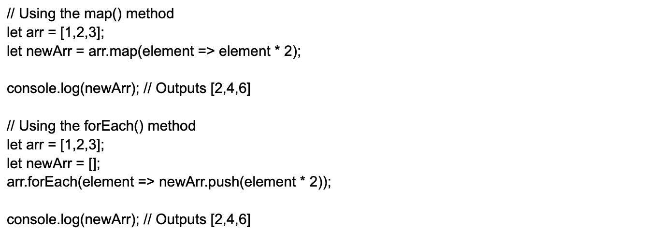

#### **10.**

How can you get rid of duplicates from a JavaScript array?

There are two ways we can eliminate duplicates from the JavaScript array:

**Through the Filter Method**:

The filter() method can use three arguments: arrays, current element, and the current element's index.

**Utilizing the For Loop**

The For loop involves iterating through the original array and checking whether each element has already been added to a new array. If it hasn't, the element is added; if it has, it is skipped.

#### **11.**

Explain how to read and write a file using JavaScript?

For reading operations, the readFile() function is used.

**readFile( Path, Options, Callback)**

For writing operations,The writeFile() functions is used.

**writeFile( Path, Data, Callback)**

#### **12.**

How can you target a particular frame from a hyperlink in JavaScript?

This can be done by using the target attribute in the hyperlink. Like

Image 23-03-23 at 10.56 PM_11zon.webp

How can we hide JavaScript code from old browsers that don't support JavaScript?

To hide the JavaScript codes from old browsers that do not have support for JavaScript, you can make use of:

Image 23-03-23 at 10.57 PM_11zon.webp

The majority of browsers from the past will consider it as a long comment of HTML. New browsers that support JavaScript will treat it as an online message. Alternatively, you could use the "noscript" element to provide alternative content that will display for users who do not have JavaScript enabled.

What will be the output of the following code?

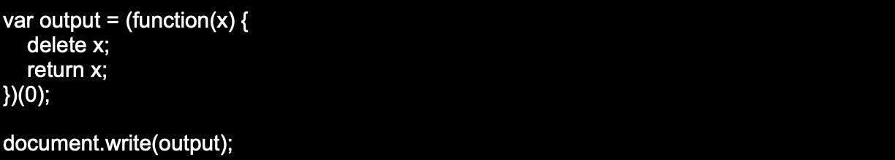

Output: 0

Can you explain the usage of Internal and External JavaScript Code?

When there are only a few lines of code for a particular webpage, it is preferable to keep JavaScript code internal within the HTML document.  
However, if the JavaScript code is used on multiple web pages, it is advisable to keep the code in a separate file.

Write a sample code for JavaScript multiplication table.

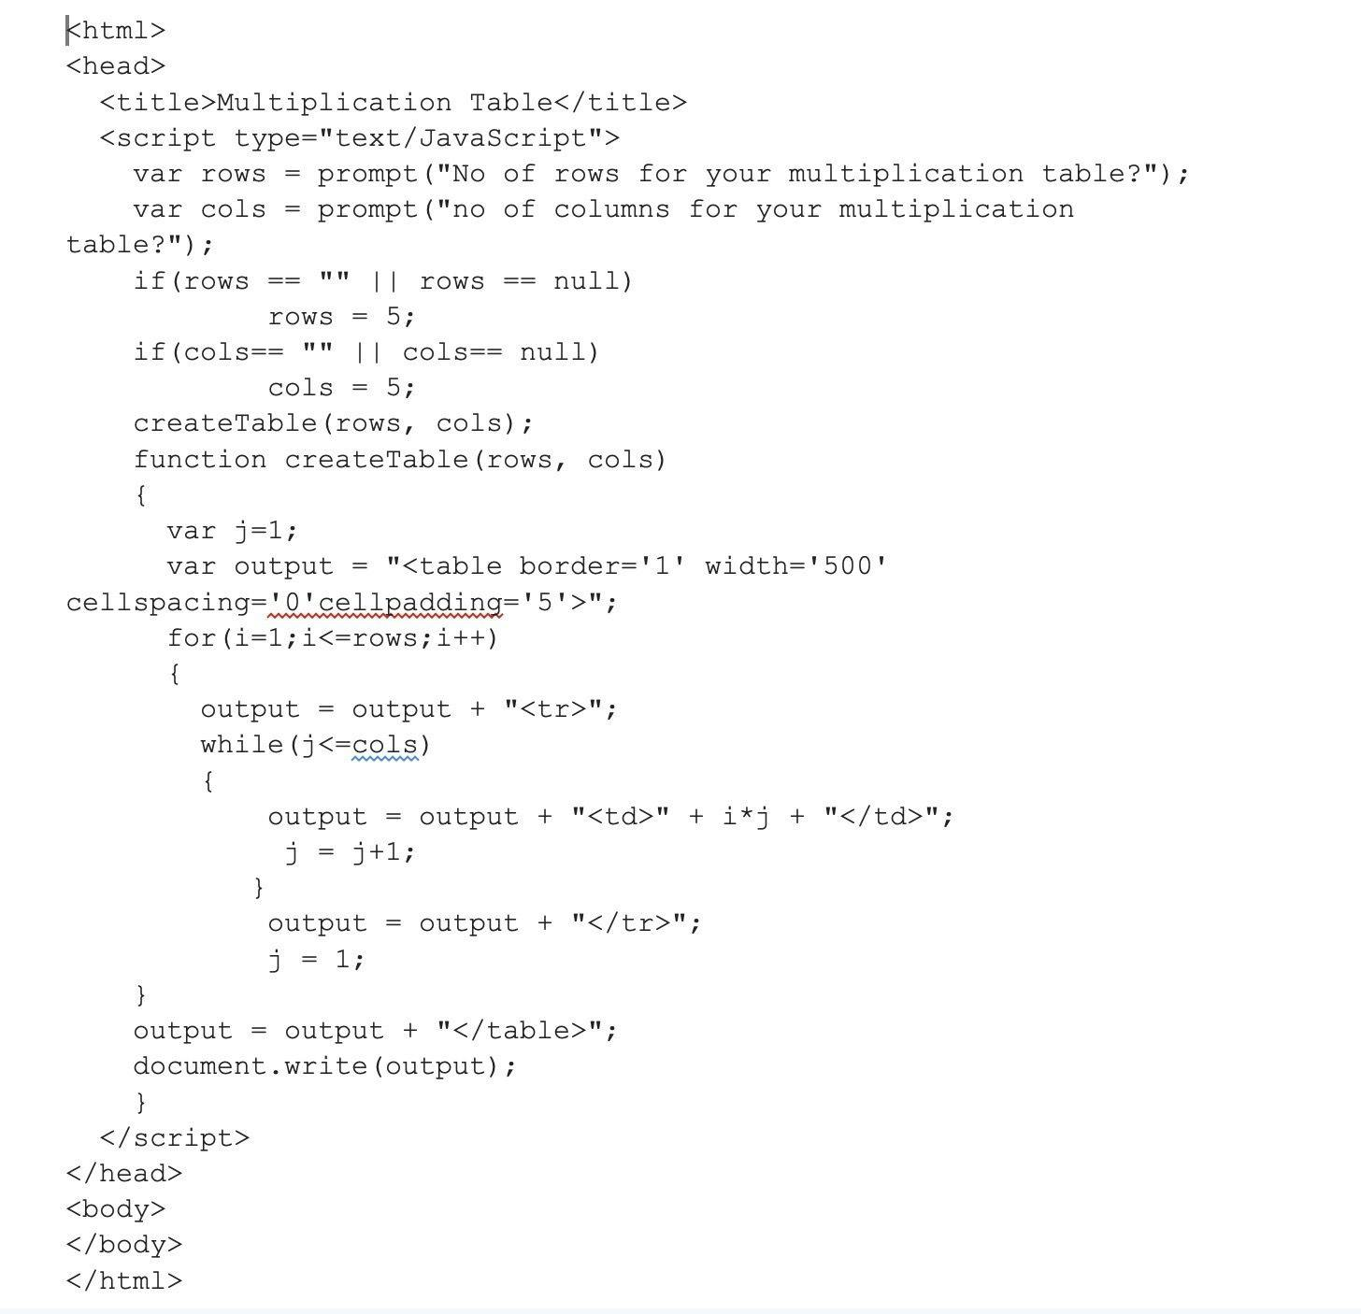

What do you know about unescape() and escape() functions?

The escape () function codes a string to transfer the information across a network from one system to another.  
Example

The unescape() function decodes the coded string.  
Example

Write a code to explain how unshift() works?

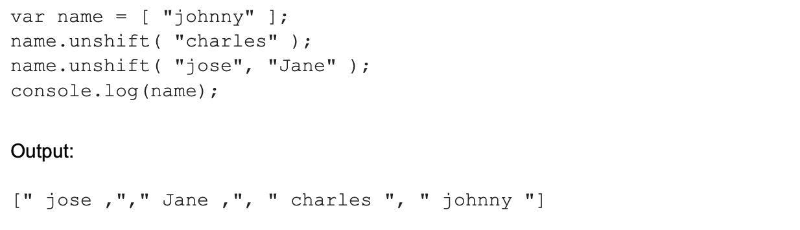

Can you explain what screen objects are?

Screen objects read the information from the screen of the client. Some properties of screen objects are

* AvailHeight: Provides the height of the screen
* AvailWidth: Provides the width of the screen
* ColorDepth: Provides the bit depth of images on the screen
* Height: Provides the total height of the screen along with the taskbar
* Width: Provides the total width of the screen, including the taskbar

Explain different functional components in JavaScript?

The functional components in JavaScript are-

**First-class functions**: functions are used as first-class objects. This means they can be passed as arguments to other functions, sent back as values from other functions, assigned to variables, or can even be saved as data structures.

**Nested functions**: These are defined inside other functions and called every time the main function is called.

Explain deferred scripts in JavaScript.

When the page loads, HTML code parsing is paused by default till the time the script has not fully executed. this happens when the server is slow or the script is heavy, and the web page gets delayed. So by using Deferred script , scripts execution is delayed till the HTML parser rums. this helps reduce the loading time of web pages and they can be displayed faster.

#### **24.**

Explain how DOM is utilized in JavaScript.

Document Object Model (DOM) is how different objects in a document interact with each other. It is used for developing web pages that include objects like paragraphs, links, etc. These Objects can be made to perform actions like add or delete. Also, it adds extra abilities to a web page.

Define window.onload and onDocumentReady.

Window.onload is an event that is fired when the page has finished loading. This event is often used to perform tasks that need to be done after the page has loaded, such as setting up event handlers, initializing components, or making AJAX requests.

On the contrary, onDocumentReady is an event that is fired when the page's HTML document is ready to be interacted with. This event is often used to perform tasks that need to be done when the page is ready, such as setting up event handlers, initializing components, or making AJAX requests.

How to get the status of a CheckBox?

The following syntax is used  
alert(document.getElementById('checkbox1').checked);

How can you append a value to an array?

We can append a value to an array by

arr[arr.length] = value;

|  |  |
| --- | --- |
| **Java** | **JavaScript** |
| Java is a complete and strongly typed programming language used for backend coding. In Java, variables must be declared first to use in the program, and the type of a variable is checked at compile-time. | JavaScript is a weakly typed, lightweight programming language (most commonly known as scripting language) and has more relaxed syntax and rules. |
| Java is an object-oriented programming (OOPS) language or structured programming languages such as C, C++, or .Net. | JavaScript is a client-side scripting language, and it doesn't fully support the OOPS concept. It resides inside the HTML documents and is used to make web pages interactive (not achievable with simple HTML). |
| Java creates applications that can run in any virtual machine (JVM) or browser. | JavaScript code can run only in the browser, but it can now run on the server via Node.js. |
| The Java code needs to be compiled. | The JavaScript code doesn't require to be complied. |
| Java Objects are class-based. You can't make any program in Java without creating a class. | JavaScript Objects are prototype-based. |
| Java is a Complete and Standalone language that can be used in backend coding. | JavaScript is assigned within a web page and integrates with its HTML content. |
| Java programs consume more memory. | JavaScript code is used in HTML web pages and requires less memory. |
| The file extension of the Java program is written as ".Java" and it translates source code into bytecodes which are then executed by JVM (Java Virtual Machine). | The JavaScript file extension is written as ".js" and it is interpreted but not compiled. Every browser has a JavaScript interpreter to execute the JS code. |
| Java supports multithreading. | JavaScript doesn't support multithreading. |
| Java uses a thread-based approach to concurrency. | JavaScript uses an event-based approach to concurrency. |

What is BOM?

**BOM** stands for *Browser Object Model*. It provides interaction with the browser. The default object of a browser is a window. So, you can call all the functions of the window by specifying the window or directly. The window object provides various properties like document, history, screen, navigator, location, innerHeight, innerWidth,

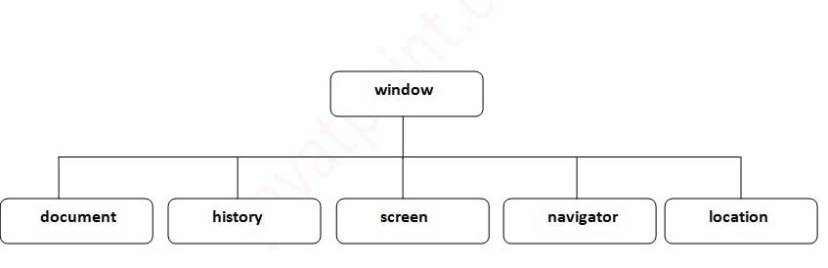

### 33) Difference between Client side JavaScript and Server side JavaScript?

**Client-side JavaScript** comprises the basic language and predefined objects which are relevant to running JavaScript in a browser. The client-side JavaScript is embedded directly by in the HTML pages. The browser interprets this script at runtime.

**Server-side JavaScript** also resembles client-side JavaScript. It has a relevant JavaScript which is to run in a server. The server-side JavaScript are deployed only after compilation.

### 34) In which location cookies are stored on the hard disk?

The storage of cookies on the hard disk depends on the OS and the browser.

The Netscape Navigator on Windows uses a cookies.txt file that contains all the cookies. The path is c:\Program Files\Netscape\Users\username\cookies.txt

The Internet Explorer stores the cookies on a file [[email protected]](https://www.javatpoint.com/cdn-cgi/l/email-protection) The path is: c:\Windows\Cookies\[[email protected]](https://www.javatpoint.com/cdn-cgi/l/email-protection)